Take Home Exam 11: Power Density

## to be Assigned: the week of Nov 09

Due (as pdf by email) 11/13/2022 (Sunday)

HW 11

11.1

The diagram for discharging a battery is shown below on the right. Draw an equivalent diagram for the same battery geometry for the charge cycle. You may give your answer by overwriting on this figure, if you wish,

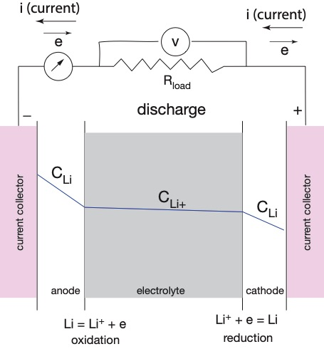

11.2

Show that the units on both sides of the following two equations are balanced:





11.3

The power density can be described in terms of different parameters, as in

Horse Power

kW/kg

(Coulombs/sec)*volts/g

(mAh/g)*V

Show how these parameters can be (fundamentally) related to one another

11.4

In order to obtain high power density the anode is fabricated from several thin layers conn

ected in parallel, as follows

(i) Explain in words why thus multilayer structure increases the power density (versus a monolithic anode with the same volume).

(ii) Draw a diagram, that is equivalent to the one below (showing the connection to the current collector and so on) for the multilayer structure,

